# Department of Computer Science & Engineering(DS,AIML,CS)



**2022**

# A

**Mini Project Report**

**On**

# “CHATBOT FOR ARUNDATHI HOSPITAL”

Submitted in partial fulfillment of the Requirements for the award of the degree of

# Bachelor of Technology

**In**

# Computer Science & Engineering – Data Science

## By

**S.Ritesh Dhyan - 20R21A6752 P.Sai Kumar - 20R21A6751**

## K.Sri Prabha - 20R21A6737 R.Vivek - 20R21A6750

Under the guidance of

**Mr.P.Srinivasa Reddy**

**Assistant Professor**

# INDEX

|  |  |
| --- | --- |
| **College Certificate** | **i** |
| **Acknowledgement** | **ii** |
| **Declaration** | **iii** |
| **List of Figures** | **iv** |
| **Abstract** | **1** |
| **Chapter 1** |  |
| **Introduction** | 2-3 |
| 1.1 Overview | 2 |
| 1.2 Types of Chatbots | 2 |
| 1.3 Applications | 3 |
| **Chapter 2** |  |
| **Literature Survey** | 4 |
| 2.1 Existing System | 4 |
| 2.1.1 Limitations of Existing System  **Chapter 3** | 5 |
| **Proposed System** | 5 |
| 3.1 Proposed System | 5 |
| 3.1.1 Advantages of Proposed System | 5 |
| 3.2 System Requirements | 6 |
| 3.2.1 Software Requirements | 6 |
| 3.2.2 Hardware Requirements | 6 |
| **Chapter 4** | 6 |
| **Architecture Design** | 7 |
| 4.1 Working of the chatbot | 7-8 |
| **Chapter 5** | 9 |
| **Modules** | 9 |
| 5.1 Tensorflow | 9 |
| 5.2 Nltk | 9 |
| 5.3 Tkinter | 9 |
| 5.4 Json | 10 |
| 5.5 Pickle | 10 |
| 5.6 Random | 10 |
| 5.7 Numpy | 10 |
| 5.8 Pandas | 10 |
| **Chapter 6** |  |
| **Implementation** | **11-15** |
| **Chapter 7** |  |
| **Code** | **16-28** |
| 7.1 chatbot_py.py | 16-17 |
| 7.2 Training_py.py | 17-19 |
| 7.3 intents.json | 20-27 |
| **Chapter 8** |  |
| **Output/Results** | 28-33 |
| **Chapter 9** |  |
| **Conclusion** | 34 |
| **Chapter 10** |  |
| **References** | 35 |

**CERTIFICATE**

This is to certify that the project entitled **“Chatbot for Arundathi Hospital”** has been submittedby **S. Ritesh Dhyan(20R21A6752), P. Sai Kumar(20R21A6751),K. Sri Prabha (20R21A6737),R. Vivek(20R21A6750)** in partial fulfillment of the requirements for the award of degree of Bachelor of Technology in Computer Science and Engineering from Jawaharlal Nehru Technological University, Hyderabad. The results embodied in this project have not been submitted to any other University or Institution for the award of any degree or diploma.

**Internal Guide Head of the Department**

**External Examiner**

# ACKNOWLEDGEMENT

There are many people who helped me directly and indirectly to complete my project successfully. I would like to take this opportunity to thank one and all.First of all I would like to express my deep gratitude towards my internal guide **Mr.P.Srinivasa Reddy Asst.Prof,Department of CSE(DS,AIML,CS)** for his support in the completion of my dissertation. I wish to express my sincere thanksto **K.Sai Prasad HOD, Department of CSE(DS,AIML,CS)** and also to principal **Dr. K.Srinivas Rao** for providing the facilities to complete the dissertation. I would like to thank all our faculty, coordinators and friends for their help and constructive criticism during the project period. Finally, I am very much indebtedto our parents for their moral support and encouragement to achieve goals.

**S. Ritesh Dhyan - 20R21A6752**

**P. Sai Kumar - 20R21A6751**

### K. Sri Prabha - 20R21A6737

**R. Vivek - 20R21A6750**



# Department of Computer Science & Engineering(DS,AIML,DS) DECLARATION

I hereby declare that the project entitled **“Chatbot for Arundathi Hospital”** is the work done during the period from **AUG 2022 to DEC 2022** and is submitted in the partialfulfillment of the requirements for the award of degree of Bachelor of technology in Computer Science and Engineering from MLR Institute of Technology, Hyderabad. The results embodied in this project have not been submitted to any other university or Institution for the award of any degree or diploma.

**S. Ritesh Dhyan - 20R21A6752**

**P. Sai Kumar - 20R21A6751**

### K. Sri Prabha - 20R21A6737

**R. Vivek - 20R21A6750**

|  |  |  |
| --- | --- | --- |
| **Figure** | **Name of the figure** | **Page**  **Number** |
| 1 | Architecture Design | 7 |
| 2 | download py charm | 11 |
| 3 | choose installation path | 11 |
| 4 | choose start menu folder | 12 |
| 5 | Installation | 12 |
| 6 | Complete the setup | 13 |
| 7 | create a project | 13 |
| 8 | select the file | 14 |
| 9 | select chatbot project | 14 |
| 10 | package installation | 15 |
| 11 | check packages | 15 |
| 12 | Main Interface | 28 |
| 13 | color interface 1 | 29 |
| 14 | color interface 2 | 29 |
| 15 | color interface 3 | 30 |
| 16 | color interface 4 | 30 |
| 17 | conversation | 31 |
| 18 | file section | 31 |
| 19 | options section 1 | 32 |
| 20 | options section 2 | 32 |
| 21 | help section | 33 |
| 22 | about arubot | 33 |
| 23 | arubot developers | 33 |

# LIST OF FIGURES

# ABSTRACT

Chat bot[2] is an automated way of communication with the users in human understandable language. Chat bots[2] are used in applications such as e-commerce customer service, call centers and Internet gaming. Chat bots[2] are programs built to automatically engage with received messages. Chat bots[2] can be programmed to respond the same way each time, to respond differently to messages containing certain keywords and even to use machine learning[7] to adapt their responses to fit the situation. A developing number of hospitals, nursing homes, and even private centers, presently utilize Chat bots[2] for human services. These bots connect with potential patients visiting the hospital, helping them discover specialists, facilities available in the hospital, doctors availability time, Specialized treatments and getting them access to the correct treatment. This healthcare chat bot[2] system will help hospitals to provide healthcare support 24 x 7, it answers deep as well as general questions. The Chat bot is designed using various packages from python such as tensor flow[9], nltk(Natural Language Tool Kit)[9], json[10] , tkinter[9] etc.

# 1.INTRODUCTION

# 1.1 Overview

A chat bot (conversational interface, AI agent) is a computer program that can understand human language and communicate with a user via a website or a messaging app. Chat bot can help users by delivering the consistent information about an organization which avoids dishing out irrelevant information to customers. Chat bots can be as simple as basic programs that answer a simple query with a single-line response, used as digital assistants that learn and evolve to deliver increasing levels of personalization as they gather and process information.

**1.2 Types of Chatbots**

There are two main types of chat bots:

* **Task-oriented** (declarative) chat bots are single-purpose programs that focuson performing one function. Using rules, NLP, and very little ML, they generate automated but conversational responses to user inquiries. Though they do use NLP so end users can experience them in a conversational way, their capabilities are fairly basic. These are currently the most commonly used chat bots.
* **Data-driven and predictive** (conversational) chat bots are often referred to as virtual assistants or digital assistance and they are much more sophisticated, interactive, and personalized than task-oriented chat bots. They apply predictive intelligence and analytics to enable personalization based on user profiles and past user behavior. Digital assistants can learn a user’s preferences over time, provide recommendations. In addition to monitoring data and intent, they can initiate conversations. Examples like apple’s siri and Amazon’s alexa. The chatbot which we are creating is a task oriented type.

**1.3 Applications** :

* **Messaging apps** : Many companies use chatbots run on messaging apps or simply using SMS. They are used for B@C customer service. A 2017 study showed that 4%of companies used chatbots. According to a 2016 study, 80% of businesses said they intended to have one by 2020.
* **Company internal platforms** : Several companies are exploring ways to usechatbots internally, such as for Customer Service, Human Resources, and Internet- of-Things (IoT). In order to automate certain simple, yet time-consuming processes when requesting sick leave, Overstock.com, for example, has launched a chatbot

called Mila. Many large companies such as Lloyds Banking Group, Royal Bank of Scotland, Renault and Citroën are now using automated online assistants instead ofcall centres with humans to provide a first point of contact. A SaaS chatbot ecosystem has steadily grown since Facebook's Mark Zuckerberg announced that Messenger would allow chatbots into the app. A reference architecture for Intelligent Chatbots is being designed by IT architects in large companies, such as hospitals and aviation organizations, which unlock and share knowledge and experience more efficiently within the organization and reduce the errors made by expert service desks. Artificial intelligence, such as image moderation, natural language understanding, natural language generation, machine learning, and deep learning, is used to create Intelligent Chatbots.

* **Customer service :** Many high-tech banking groups are trying to combine computerized AI-primarily based totally answers along with chatbots into their customer support on the way to offer quicker and less expensive help to their customers who have become more and more more cushty with technology. In particular, chatbots can successfully behaviour a dialogue, typically changing different communique equipment along with email, phone, or SMS. In banking, their important software is associated with short customer support answering not un usualplace requests, in addition to transactional support.
* **Health Care** : Chatbots also are acting withinside the healthcare industry. A take a look at counseled that physicians withinside the United States believed that chatbots might be maximum useful for scheduling medical doctor appointments, finding fitness clinics, or presenting medicine information..

# 2.LITERATURE SURVEY

Now a days the use of chatbot is popular in large of applications especially in systemsthat provide an intelligence support to user. There is no previous research on the topic which we have selected. So, we are the first team to do a project on the chatbot for Arundathi hospital. We are mainly concentrating on making the chatbot answer the basic queries regarding the hospital such as Location of the hospital, Facilities available in the hospital, Contact numbers of the hospital, Doctors of each department etc. We used machine learning approach to train the bot.To make this chat bot we used NLP i.e Natural language processing to preprocess the data to the chatbot and make the bot understand the human language and respond back to the user in the same way. We trained the bot using json data set. The data in the json file is stored in the form of dictionary data structure. There are many other packages which we used to make the chatbot such as numpy, pandas, Tensorflow, nltk, Tkinter, random, json. Further we would like to create a web application of the hospital and import this chatbot into the web application. We also want to make the chat bot more effective by adding some more features like booking an appointmentfor doctor consultancy, Showing the reports of patients if they have taken any tests in the hospital, Doctors live availability in the hospital

# 2.1 EXISTING SYSTEM

# Slush : Customer expect an immediate response when they reach out to a company for any support. To deliver real-time and high-quality support to a large number of any support. To deliver real time and high quality support to a large number of customers is not an easy job. An AI enabled chatbot is the best option to handle the “n” number of conversations with 24/7 engagement.

**Mariott** :Here is a customer service chatbot example in the hospitality industry to get you started.Marriott used chatbot implementation ideas and made them available to guests via text message. Bots allow guests to request basic hotel services, essentially acting as an in-phone concierge. This exempts middleman involvement and enables requests to be met quickly and efficiently.

**Babylon Health** : The healthcare industry has made the best of the opportunity to capitalize on chatbots. The rise of health & fitness apps is the best chatbot example. Healthcare bots can help in personalizing the user experience based on the health needs of the user. [Babylon Health](https://www.babylonhealth.com/) is a well-known British online subscription service that has used bots to offer consultations based on personal medical history, and can even connect you with a live video consultation from a doctor.

**2.1.1 LIMITATIONS OF EXISTING SYSTEM**

# The bot might not understand every question asked by the user.

# Difficult to create.

# Limited Responses.

# CHAPTER 3

# PROPOSED SYSTEM

# 3.1 PROPOSED SYSTEM

The Proposed system is a basic chatbot which would answer the basic queries only regarding to the hospital. The questions can be such as location of the hospital, facilities available in the hospital, doctors availability,Multi speciality treatments inthe hospital, about hospital, founder of the hospital etc. This chat bot uses Natural language processing to understand the human language and respond back in the sameway.

**3.1.1ADVANTAGES OF PROPOSED SYSTEM**

* + Quick response to the questions.
  + The Bot will help you to know about the hospital.
  + 24/7 availability.
  + Meet the Customer Expectations.
  + Reduce User Service Costs
  + Interacts almost similar to a human with a user.

**3.2 SYSTEM REQUIREMENTS**

**3.3.1 SOFTWARE REQUIREMENTS**

Python Programming Language and pre installed libraries We used Windows operating System to run this project.

We used Py charm Community to create the virtual environment for the project.

**Py charm Installation process**

* Download the required setup file of Pycharm Community.
* Run the package and set a path where to install the Software.
* Now, begin the installation procedure similar to any other software packages.Once the installation is successful, PyCharm asks you to import settings of the existing package if any.

### Install the required packages

pip install numpy pip install pandas pip install json

pip install Tensorflow pip install tkinter

pip install random

pip install pickle pip install nltk

* All the above packages are available in python. You can use those commands to

install all the packages.

**3.3.2 HARDWARE REQUIREMENTS**

A PC or Laptop with following Specifications

* + CPU – INTEL i5 or above processor
  + RAM – 8GB MINIMUM
  + ROM – 256GB

**CHAPTER 4**

# ARCHITECTURE DESIGN

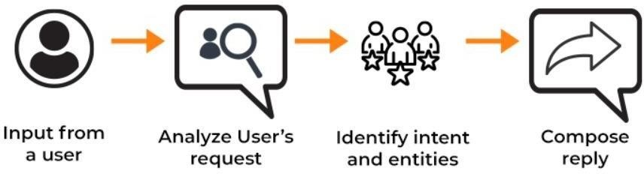

fig 6.1 : Architecture Design

**4.1 Working of the chatbot**

**Step1** : The user enters some text.

**Step2** : The input is analyzed by Natural Language Tool Kit(Natural Language Processing) which helps in assessing the intents and entities of the text entered by theuser and create response based on the contextual analysis of the text.

### Step 3 :

Now it’s time to really get into the nitty-gritty of how AI chatbots work. There are five major steps involved — tokenizing, normalizing, recognizing entities, dependency parsing, and generation — for the chatbot to read, interpret, understand, and formulate and send a response. Let’s take a closer look.

* **Tokenizing:**The chatbot starts by chopping up text into pieces (also called ‘tokens’) and removing punctuation
* **Normalizing:** Next, the bot removes details that aren't relevant and converts words to their "normal" version, for example by making everything lowercase
* **Recognizing Entities:** Now that the words are all normalized, the chatbot seeks to identify which type of thing is being referred to. For example, it would identify North America as a *location*, 67% as a *percentage*, and Google as an *organization*
* **Dependency Parsing:**For the next step, the bot identifies the role each word plays in the sentence, such as noun, verb, adjective, or object
* **Generation:** Finally, the chatbot generates a number of responses using the information determined in all the other steps and selects the most appropriate response to send to the user.

**Step 4** : If the Step 3 is accurately executed by the bot then it displays a correct output randomly from a list of responses.

**CHAPTER 5**

# MODULES

The modules or libraries used in this project are :

**5.1 Tensorflow**

TensorFlow is an open-source library for fast numerical computing. It was created and is maintained by Google and was released under the Apache 2.0 open source license. The API is nominally for the Python programming language, although there is access to the underlying C++ API. Unlike other numerical libraries intended for use in Deep Learning like Theano, TensorFlow was designed for use both in research and development and in production systems, not least of which is [Rank Brain in](https://en.wikipedia.org/wiki/RankBrain) [Google search](https://en.wikipedia.org/wiki/RankBrain) and the fun [Deep Dream project.](https://en.wikipedia.org/wiki/DeepDream) It can run on single CPU systems and GPUs, as well as mobile devices and large-scale distributed systems of hundreds of machines.

**5.2 Nltk**

programming for language processing. Written by the creators of NLTK, it guides the reader through the fundamentals of writing Python programs, working with corpora, categorizing text, analyzing linguistic structure, and more. NLTK is a leading platform for building Python programs to work with human language data. It provides easy-to-use interfaces to over 50 corpora and lexical resources such as WordNet, along with a suite of text processing libraries for classification, tokenization, stemming, tagging, parsing, and semantic reasoning, wrappers for industrial-strength NLP libraries, and an active discussion forum.

**5.3 Tkinter**

Tkinter is the standard GUI library for Python. Python when combined with Tkinter provides a fast and easy way to create GUI applications. Tkinter provides a powerful object-oriented interface to the Tk GUI toolkit.

Creating a GUI application using Tkinter is an easy task. All you need to do is perform the following steps −

* + Import the tkinter module.
  + Create the GUI application main window.
  + Add one or more of the above-mentioned widgets to the GUI application.
  + Enter the main event loop to take action against each event triggered by the user.

**5.4 Json**

The full form of JSON is Java Script Object Notation. It means that a script fil which is made of text in a programming language, is used to store and transfer thedata. Python supports JSON through a built in package called json.To use this feature, we import the json package in Python script. The text in json is done throughquoted – string which contains the value in key-value mapping with {}.

**5.5 Pickle**

Pickle in Python is primarily used in [serializing and deserializing a Python](https://wiki.python.org/moin/UsingPickle) [object structure.](https://wiki.python.org/moin/UsingPickle) In other words, it’s the process of converting a Python object into abyte stream to store it in a file/database, maintain program state across sessions, or transport data over the network. The pickled byte stream can be used to re-create the original object hierarchy by unpickling the stream. This whole process is similar to object serialization in Java or .Net.

**5.6 Random**

The random module is a built-in module to generate the pseudo- random variables. It can be used perform some action randomly such as to get a random number, selecting a random elements from a list, shuffle elements randomly, etc.

**5.7 Numpy**

NumPy, which stands for Numerical Python, is a library consisting of multidimensional array objects and a collection of routines for processing those arrays. Using NumPy, mathematical and logical operations on [arrays](https://www.mygreatlearning.com/blog/what-is-an-array-learn-more-in-one-read/) can be performed. In this Python Numpy Tutorial, we will be learning about NumPy in Python, What is NumPy in Python, Data Types in NumPy, and more.

**5.8 Pandas**

pandas is a fast, powerful, flexible and easy to use open source data analysis and manipulation tool, built on top of the [Python](https://www.python.org/) programming language. Pandas is built on top of two core Python libraries—[matplotlib](https://mode.com/python-tutorial/libraries/matplotlib) for data visualization and [NumPy](https://mode.com/python-tutorial/libraries/numpy) for mathematical operations. Pandas acts as a wrapper over these libraries, allowing you to access many of matplotlib's and NumPy's methods with less code.

# CHAPTER 6

# IMPLEMENTATION

Follow the below steps to download Py charm Application software.

Step 1 : Download the required package or executable from the official website PyCharm [https://www.jetbrains.com/pycharm/download/#section=window](https://www.jetbrains.com/pycharm/download/#section%3Dwindows) Here you will observe two versions of package for Windows as shown in the screenshot given below −

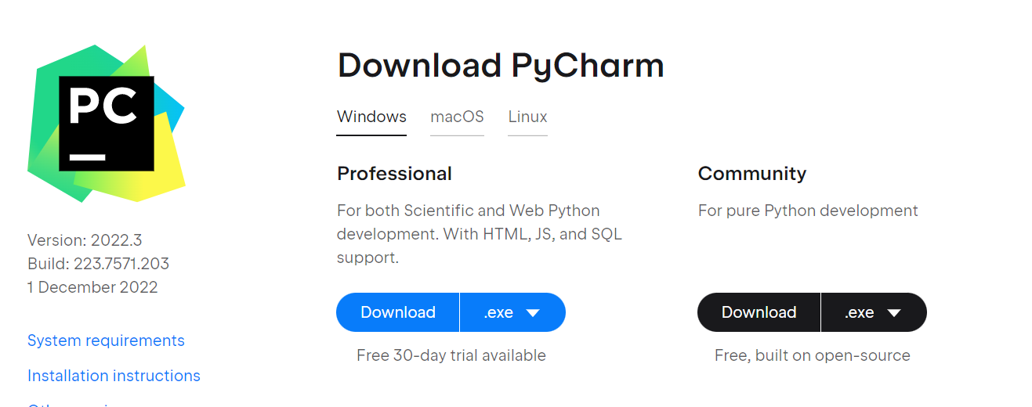

Fig 8.1 : Download py charm

Step 2 : Download the community package (executable file) onto your system and mention a destination folder as shown below –

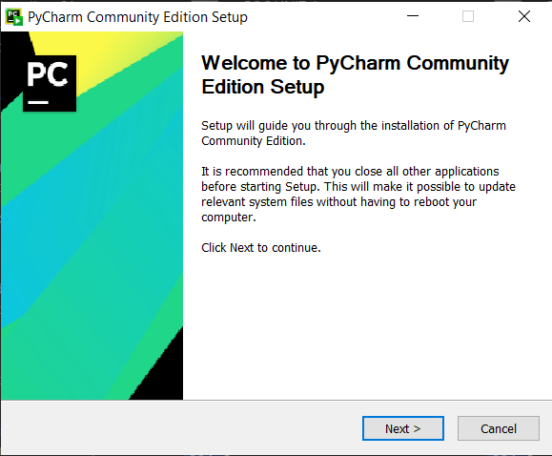

Fig 8.2 : Pycharm Setup

Step 3 : Now, begin the installation procedure similar to any other software package

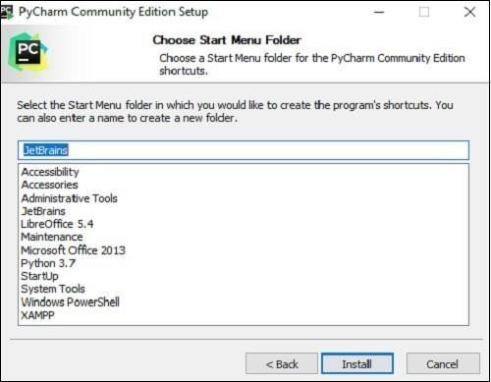

Fig 8.3 : Choose start Menu Folder

Step 4 : let the installation process complete

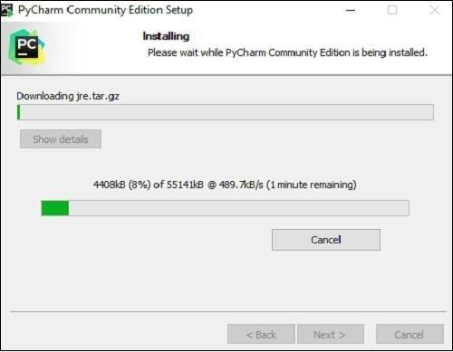

Fig 8.4 : Installing

Step 5 : Once the installation is successful, PyCharm asks you to import settings of the existing package if any.

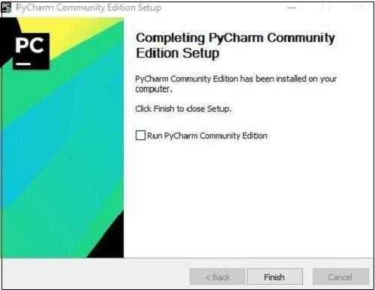

Fig 8.5 : Complete the setup

Step 6 : Open the Application and click on create a new project

* + - Once you click on it you will get a page like this.
    - Then select the python interpreter or new virtual environment.
    - 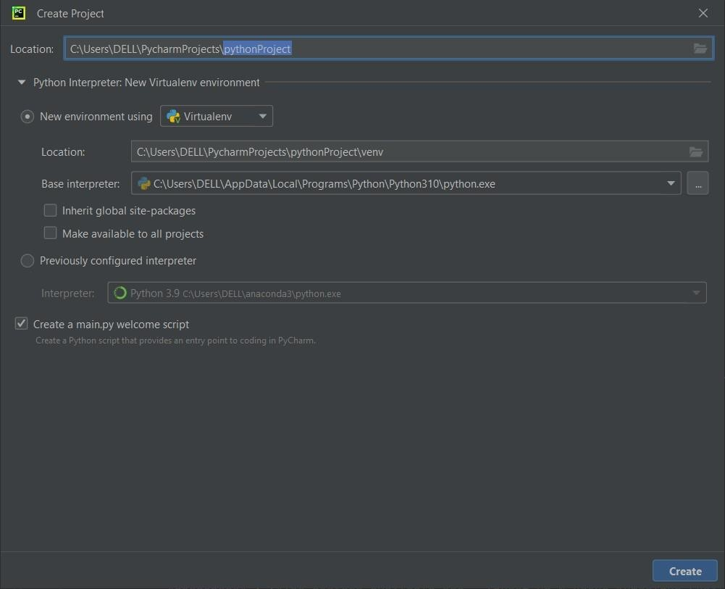After selecting the python interpreter click on create.

Fig 8.6 : create a project

Step 7 : At the top most left corner click on file.

* + - Click on the open
    - 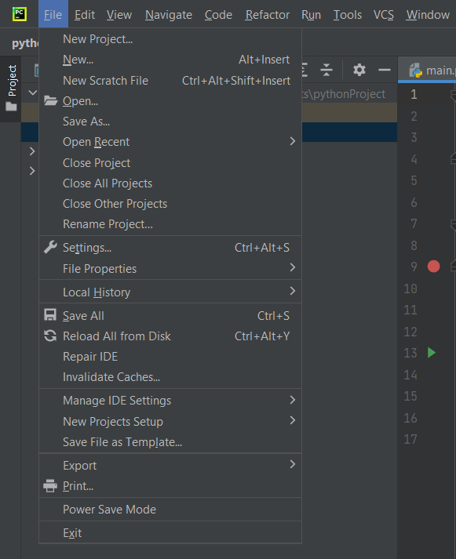A new tab will be opened where you need to select the file where the whole chatbot scripts are present.

Fig 8.7 : select the file

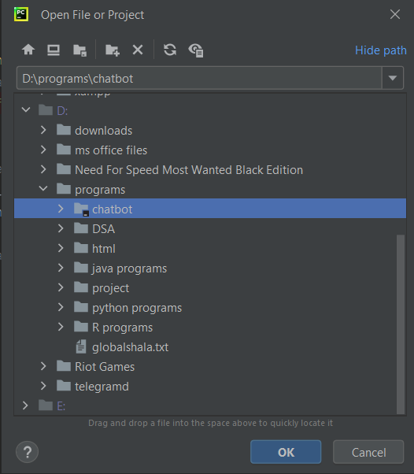

Fig 8.8 : select chatbot

Click on ok and the chatbot scripts will be included in the virtual environment.

Step 8 : After importing the project into the environment. Install all the required packages. Refer to Modules page to know what packages need to be installed for this project.

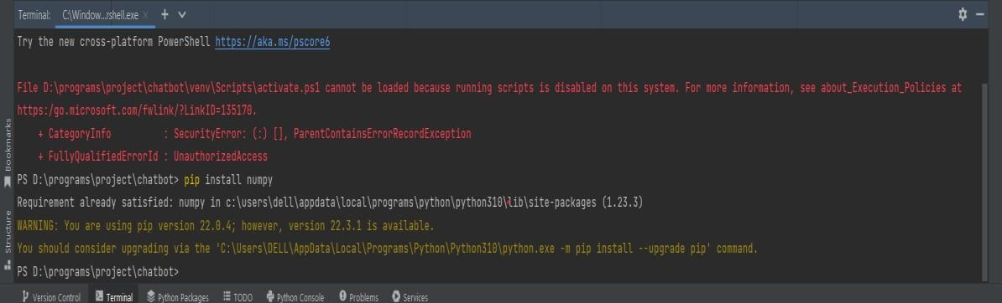Use the command **pip install package_name** to install the required package in the terminal.

Fig 8.9 : package installation

Step 9 : Once you have installed all the packages you can check if the packages are installed in the environment by clicking on the python packages option in the bottom.

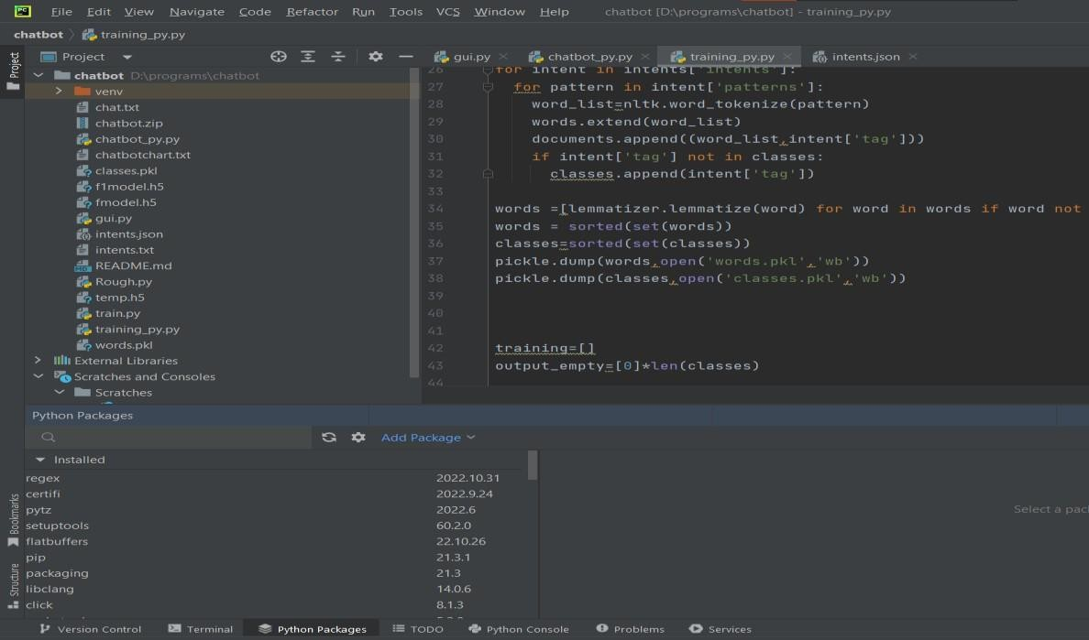

Fig 8.10 : check packages

Do not ignore the above steps, every step is crucial. So, follow the above steps and install the packages properly in order to run the project without errors.

Once you are down with the above process you can run the gui.py file to start conversation with the chatbot.

# CHAPTER 7

# CODE

**7.1 chatbot_py.py file**

This python file consists of pre processing the data to the chatbot using Natural Language processing library i.e nltk which makes the machine understand the human language and respond back in the same way

import warnings

warnings.filterwarnings('ignore')

import nltk

import random

import numpy as np

import json

import pickle

from nltk.stem import WordNetLemmatizer

from tensorflow.keras.models import load_model

lemmatizer=WordNetLemmatizer()

nltk.download('punkt')

with open('intents.json') as json_file:

intents = json.load(json_file)

words=pickle.load(open('words.pkl','rb'))

classes=pickle.load(open('classes.pkl','rb'))

model=load_model('finalmodel.h5')

def clean_up_sentence(sentence):

sentence_words=nltk.word_tokenize(sentence)

sentence_words=[lemmatizer.lemmatize(word) for word in sentence_words]

return sentence_words

def bag_of_words(sentence):

sentence_words=clean_up_sentence(sentence)

bag=[0]*len(words)

for w in sentence_words:

for i,word in enumerate(words):

if word == w:

bag[i]=1

return np.array(bag)

def predict_class(sentence):

bow=bag_of_words(sentence)

res=model.predict(np.array([bow]), verbose=0)[0]

ERROR_THRESHOLD=0.75

results=[[i,r] for i,r in enumerate(res) if r> ERROR_THRESHOLD]

results.sort(key=lambda x:x[1],reverse=True)

return_list=[]

for r in results:

return_list.append({'intent': classes[r[0]],'probability':str(r[1])})

return return_list

def get_response(intents_list,intents_json):

tag=intents_list[0]['intent']

list_of_intents=intents_json['intents']

for i in list_of_intents:

if i['tag']==tag:

result=random.choice(i['responses'])

break

return result

print("GO! BOT IS RUNNING")

while True:

message=input("")

ints=predict_class(message)

# print(ints)

res=get_response(ints,intents)

print(res)

**7.2 Training_py.py**

This python file consists of the code which trains the data or feeds the data to the machine using tensorflow library to make the machine respond to the questions asked by the user.

import random

import json

import pickle

import nltk

import pandas as pd

nltk.download('punkt')

nltk.download('wordnet')

from nltk.stem import WordNetLemmatizer

from tensorflow.keras.models import Sequential

from tensorflow.keras.layers import Dense,Activation,Dropout

from tensorflow.keras.optimizers import SGD, Adam

lemmatizer=WordNetLemmatizer()

with open('intents.json') as json_file:

intents = json.load(json_file)

words=[]

classes=[]

documents=[]

ignore_letters=['?','!','.',',']

for intent in intents['intents']:

for pattern in intent['patterns']:

word_list=nltk.word_tokenize(pattern)

words.extend(word_list)

documents.append((word_list,intent['tag']))

if intent['tag'] not in classes:

classes.append(intent['tag'])

words =[lemmatizer.lemmatize(word) for word in words if word not in ignore_letters]

words = sorted(set(words))

classes=sorted(set(classes))

pickle.dump(words,open('words.pkl','wb'))

pickle.dump(classes,open('classes.pkl','wb'))

training=[]

output_empty=[0]*len(classes)

for document in documents:

bag=[]

word_patterns=document[0]

words = [lemmatizer.lemmatize(word) for word in words if word and word not in ignore_letters]

for word in words:

bag.append(1) if word in word_patterns else bag.append(0)

output_row=list(output_empty)

output_row[classes.index(document[1])]=1

training.append([bag,output_row])

random.shuffle(training)

training=np.array(training)

train_x=list(training[:,0])

train_y=list(training[:,1])

print(len(train_x))

model=Sequential()

model.add(Dense(256,input_shape=(len(train_x[0]),),activation='relu'))

model.add(Dropout(0.5))

model.add(Dense(128,activation='relu'))

model.add(Dropout(0.5))

model.add(Dense(64,activation='relu'))

model.add(Dropout(0.5))

model.add(Dense(len(train_y[0]),activation='softmax'))

sgd=SGD(lr=0.01,decay=1e-6,momentum=0.9,nesterov=True)

model.compile(loss='categorical_crossentropy',optimizer=sgd,metrics=['accuracy'])

hist = model.fit(np.array(train_x),np.array(train_y),epochs=200,batch_size=5,verbose=1)

model.save('fmodel.h5', hist)

print('Training Done')

**7.3 intents.json**

This is the actual file which consists of the data which needs to be trained to the chatbot.

The data in json(Java Script Object Notation) file is stored in the form of dictionary which consists of key value pairs.

{"intents":

[

{

"tag":"greeting",

"patterns": ["hello","hey","hi","good day","greetings","what's up?","how is it going"],

"responses":["hello","hey!","what can i do for you?","hi!!,how can i help u?"]

},

{

"tag":"goodbye",

"patterns": ["cya","see you later","goodbye","have a good day","bye","cao","see ya"],

"responses":["have a nice day","goodbye","ok Bye!!"]

},

{

"tag":"age",

"patterns": ["how old","how old are you?","what is your age","how old are you","age?"],

"responses":["I get reborn after every compilation"]

},

{

"tag":"Location",

"patterns": ["Where are You?","Where is Arundati Hospital Located?","Where is this hospital?","How can I reach Arundati Hospital?","location of hospital"],

"responses":["Arundati Hospital : Dundigal, Gandimaisamma Medchal-Malkajgiri, Dist, Hyderabad, Telangana 500043"]

},

{

"tag":"name",

"patterns": ["what is your name","what should i call you","what's your name?","who are you?","can you tell me your name","ur name?"],

"responses":["you can call me AruBot!","i am AruBot!","i am AruBot your medical assistant"]

},

{

"tag":"about",

"patterns": ["tell me about yourself?", "tell me about?", "about you?", "about yourself","about arundathi"],

"responses":["Arundathi Institute of Medical Sciences and Hospital is situated in a sprawling campus and has a total built-up area of 10 Acres comprising of big building. The College is equipped with Air Conditioned Lecture Halls with multimedia audio-visual aids and well equipped demonstration rooms and Laboratories attached with a 350 beded Teaching Hospital located at Dundigal, Medchal-Malkajgiri District. "]

},

{

"tag" : "total facilities in hospital",

"patterns" : ["what are the facilities available?","what does the hospital have?","facilities in hospital","facilities"],

"responses" : ["\nGround Floor - OP/IP Registration,Pharmacy,Emergency,Pediatrics,Gynecology,Radiology,General,Surgery,Urology,OPD Orthopedic,OPD Sample collection,General Medicine,Cardiology,Psychiatry,Virology Lab C,Diabetology OPD,\n1stFloor - Opthalmology,ENT OPD,Dermatology,Dental OPD,Pulmonology,Medical Director,Medical Super intendent,Administration,Operation Theatres Complex,OT-Pharmacy,Dialysis Centre,Surgical ICU,Burn ICU,Labour Room\n2nd Floor - NICU|PICU,MICU|RICU,Cath Lab,Gynecology Ward,ANC Ward,General Medicine Ward,Psychiatry Ward,Pulmonology Ward,Opthalmology Ward\n3rd Floor - Central Laboratory,Blood Bank,General Surgery Ward,ENT Ward,Orthopedic Ward,Paediatric Ward,Physical Medicine and Rehabilitation"]

},

{

"tag" : "free treatments",

"patterns" : ["free dialysis","does the hospital provide dialysis treatment?","dialysis","dialysis treatment"],

"responses" : ["The hospital provides free dialysis treatment with best quality Nephrology Care,Ultra Modern Dialysis Machines,Standard Operating protocols,Sanitized beds,Diet Consultaion,Laboratory,Memodiafiltration"]

},

{

"tag" : "aarogya sri",

"patterns" : ["Are the patients with AHCT insurance given free treatment?","Does the hospital provide free treatment for ahct patients?","is ahct in hospital?","is ahct available in hospital?"],

"responses" : ["The Arundathi hospital provides free treatment to the patients who have insurance in AHCT."]

},

{

"tag" : "about ahct",

"patterns" : ["about AHCT?","about ahct","about arogya sri","aarogyasri","free treatment","what is ahct?"],

"responses" : ["the Government in an effort to assist the Below Poverty Line families (BPL) decided to introduce health insurance for treating the Catastrophic illness. In order to facilitate the effective implementation of the scheme, the Government has set up AAROGYASRI HEALTH CARE TRUST under the chairmanship of Hon'ble Chief Minister. The trust in consultation with the specialists in the field of Health Care and insurance devised a scheme by name Aarogyasri Community Health Insurance Scheme."]

},

{

"tag" : "arundathi contact numbers",

"patterns" : ["arundathi hospital contact numbers","contact numbers of arundathi hospital","how can i contact hospital?"],

"responses" : ["Contact Info\nPhone: 8055667888, 805578999\nEmail: admin@aims.ac.in"]

},

{

"tag" : "doctors in arundathi General Medicine",

"patterns" : ["general medicine doctors","doctors of general medicine","doctors of General Medicine","who are the doctors available at general medicine?","doctors at general medicine"],

"responses" : ["The doctors available are - \nDr.T Naga Jawahar Rajesh\nDr.P.V Ram Prasad\nDr.M Bharath Kanth Reddy\nDr.B Y Keerthi\nDr. G Naresh\nDr. G Varun Kumar\nDr.R Sreekanth\nDr.G Rahu"]

},

{

"tag" : "doctors in arundathi Pediatrics",

"patterns" : ["Pediatrics doctors","doctors of Pediatrics","doctors of pediatrics","doctors at pediatrics","who are the doctors available at Pediatrics?","doctors at Pediatrics"],

"responses" : ["The doctors available are - \nProf.Dr.N Udaya Kumar\nDr.Sunil V\nDr.D Mounika\nDr. M Akhilesh"]

},

{

"tag" : "doctors in arundathi General Surgery",

"patterns" : ["General Surgery doctors","doctors of General Suregery","doctors of general surgery","doctors at general surgery","who are the doctors available at General Surgery?","doctors at General Surgery"],

"responses" : ["The doctors available are - \nProf.Dr.Ch Venkata Pavan\nDr.Sanjeev Singh Yadav\nDr.Abhishek Kathe\nDr. Subrahmanyeshwara Babu\nDr.Reena Kumari\nDr.B Pradeep\nDr.K praneeth Raj Patel\nDr.M Anil\nDr.G Prabhakar\nDr.B Laxman\nDr.Shyam Babu"]

},

{

"tag" : "doctors in arundathi Orthopedics",

"patterns" : ["Orthopedics doctors","doctors of Orthopedics","doctors of orthopedics","doctors at orthopedics","who are the doctors available at Orthopedics?","doctors at Orthopedics"],

"responses" : ["The doctors available are - \nDr.JVS Vidya Sagar\nDr.Md nizamuddin\nDr.Karthik Reddy\nDr.P Nikitha Reddy\nDr.S Vinayaka Rao"]

},

{

"tag" : "doctors in arundathi Oto-Rhino-Larynology",

"patterns" : ["Oto-Rhino-Larynology","doctors of Oto-Rhino-Larynology","doctors of oto-rhino-larynology","doctors at oto-rhino-larynology","who are the doctors available at Oto-Rhino-Larynology?","doctors at Oto-Rhino-Larynology"],

"responses" : ["The doctors available are - \nDr.D Venkatesh\nDr.S Hima Bindu"]

},

{

"tag" : "doctors in arundathi Opthalmology",

"patterns" : ["Opthalmology","doctors of Opthalmology","doctors of opthalmology","doctors at opthalmology","who are the doctors available at Opthalmology?","doctors at Opthalmology"],

"responses" : ["The doctors available are - \nDr.K Prardhana Reddy\nDr.K Gouthami\nDr.Sabitha"]

},

{

"tag" : "doctors in arundathi Emergency Medicine",

"patterns" : ["Emergency Medicine","doctors of Emergency Medicine","doctors of emergency medicine","doctors at emergency medicine","who are the doctors available at Emergency Medicine?","doctors at Emergency Medicine"],

"responses" : ["The doctors available are - \nDr M.D Abdul Bari\nDr.A Srinivas\nDr.D Srikanth Reddy\nDr.Uday Kumar\nDr.N Saidulu\nDr.N Prathyusha\nDr. Md Asiam Mosin\nDr.K Venkateshwar Reddy\nDr.A Abhinav"]

},

{

"tag" : "doctors in arundathi Radio-Diagnostics",

"patterns" : ["Radio-Diagnostics","doctors of Radio-Diagnostics","doctors of radio-diagnostics","doctors at radio-diagnostics","who are the doctors available at Radio-Diagnostics?","doctors at Radio-Diagnostics"],

"responses" : ["The doctors available are - \nDr.G Ram Gopa\nDr.V Pavan Rao\nDr.M Nikhil\nDr.M Nikhil\nDr.Md Hussain"]

},

{

"tag" : "doctors in arundathi Obstetrics & Gynecology",

"patterns" : ["Obstetrics & Gynecology","doctors of Obstetrics & Gynecology","doctors of obstetrics & gynecology","doctors at obstetrics & gynecology","who are the doctors available at Obstetrics & Gynecology?","doctors at Obstetrics & Gynecology"],

"responses" : ["The doctors available are - \nDr.T Jaya Lakshmi\nDr.V Radhika Rani\nDr.E Suhasri\nDr.Menav\nDr Bhavitha\nDr.M Uma Rani\nDr. Keerthi Priya\nDr Hari Priya"]

},

{

"tag" : "doctors in arundathi Respiratory Medicine",

"patterns" : ["Respiratory Medicine","doctors of Respiratory Medicine","doctors of respiratory Medicine","doctors at respiratory Medicine","who are the doctors available at Respiratory Medicine?","doctors at Respiratory Medicine"],

"responses" : ["The dcotors available are - \nDr.Chirag\nDr.S Kranthi Kumar\nDr.G Kanaka Durga"]

},

{

"tag" : "doctors in arundathi Anesthesiology",

"patterns" : ["Anesthesiology","doctors of Anesthesiology","doctors of anesthesiology","doctors at anesthesiology","who are the doctors available at Anesthesiology?","doctors at Anesthesiology"],

"responses" : ["The dcotors available are - \nDr.T Rajashekar Reddy\nDr.AVS Rama\nDr Sivanand\nDr.B Ramanjaneyuvu\nDr Syed Aamari Ahmed\nDr.J Jagadish\nDr.Md Irfan"]

},

{

"tag" : "doctors in Dentistry",

"patterns" : ["Dentistry","doctors of Dentistry","doctors of dentistry","doctors at dentistry","who are the doctors available at Dentistry?","doctors at Dentistry"],

"responses" : ["The dcotors available are - \nDr.M Shilpa Reddy\nDr.R Archana\nDr.J Pranavi"]

},

{

"tag": "sorry",

"patterns": [],

"responses": ["Sorry! I Did not Get You."]

}

]}

# CHAPTER 8

# OUTPUT

1. To run this project run the gui.py file which runs the interface where the user and chatbot communication happens.

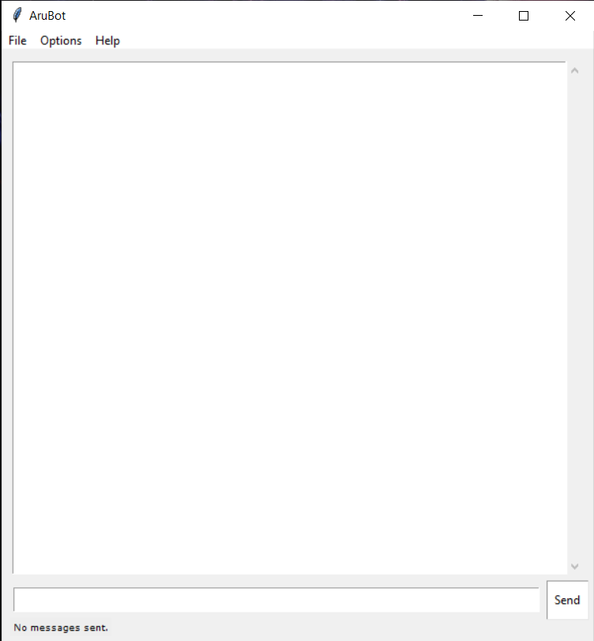We named this chatbot as Arubot.

Fig 10.1 : Main interface

1. 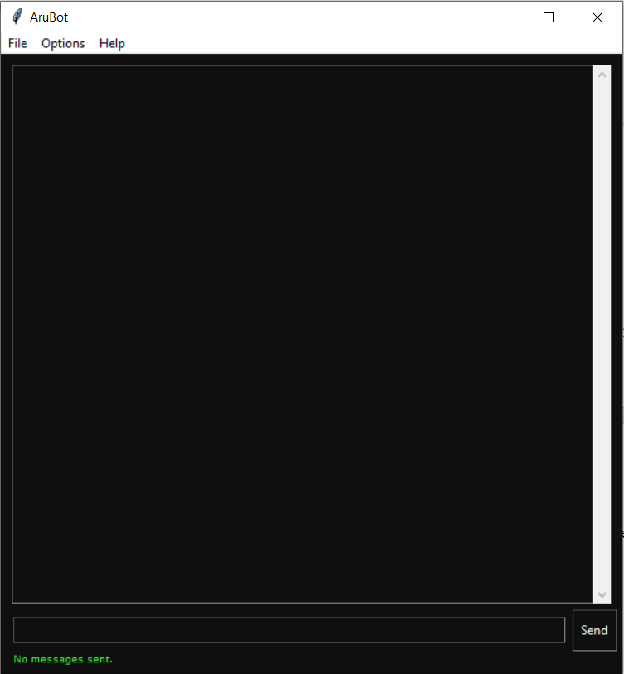We also have different colours interfaces.

Fig 10.2 : color interface 1

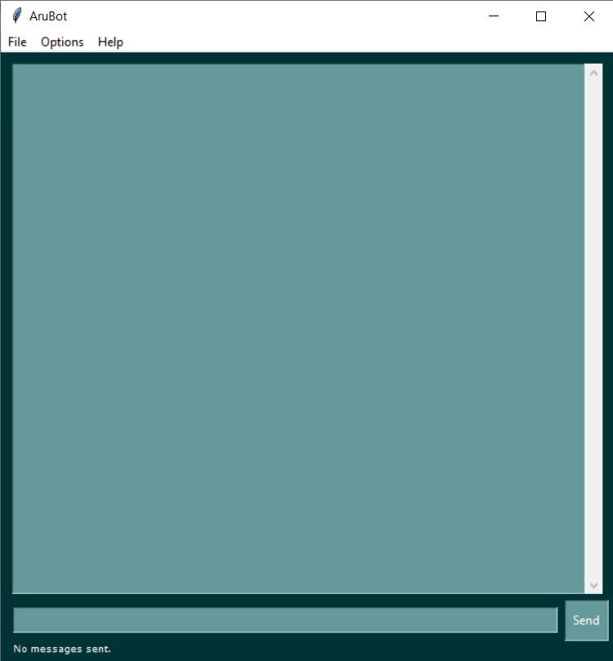

Fig 10.3 : color interface 2

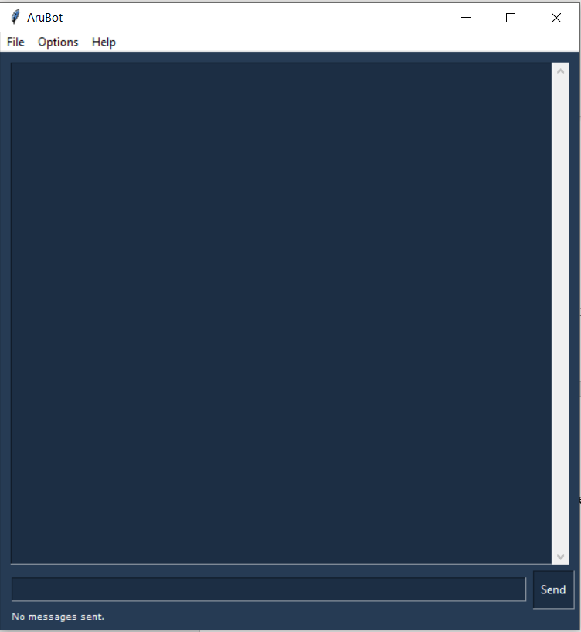

Fig 10.4 : color interface 3

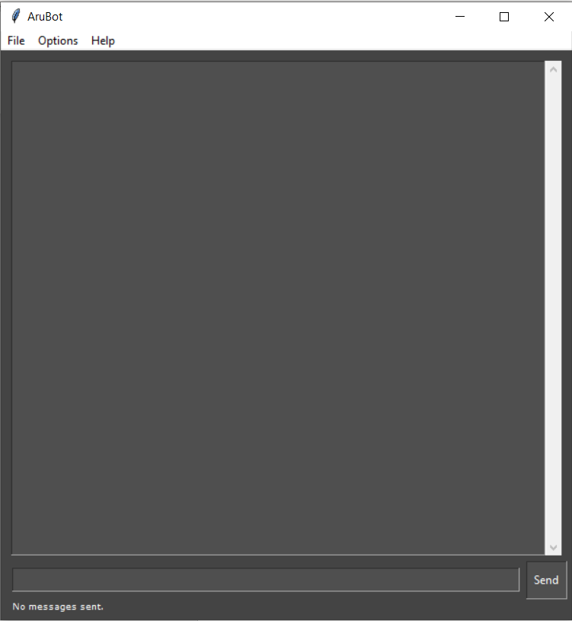

Fig 10.5 : color interface 4

1. In the interface you can see that the user enters a question and the chatbot answers according to the way it is trained.

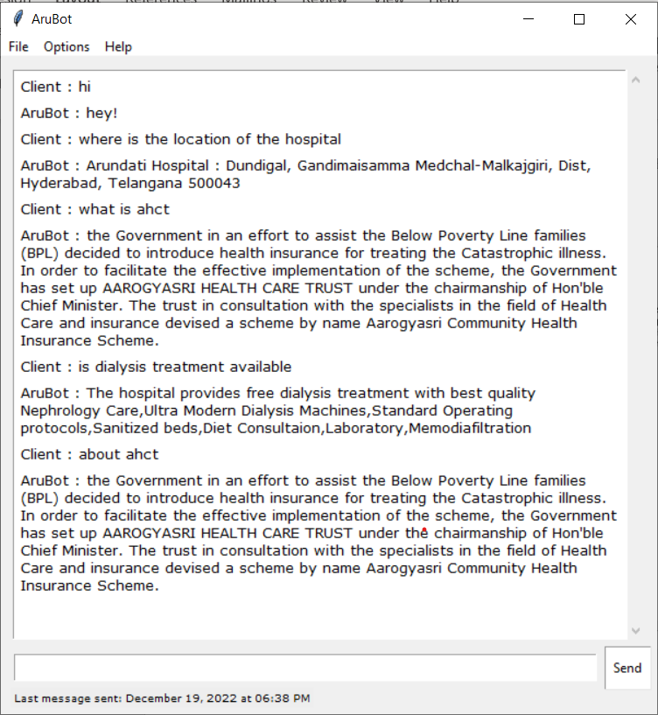

Fig 10.6 : conversation

1. We also have various other options in the interface like File, Options, Help
   * The File option consists of Exit and clear chat. When we click on the Exit option the interface will close and if we click on clear chat the whole chat will be cleared.

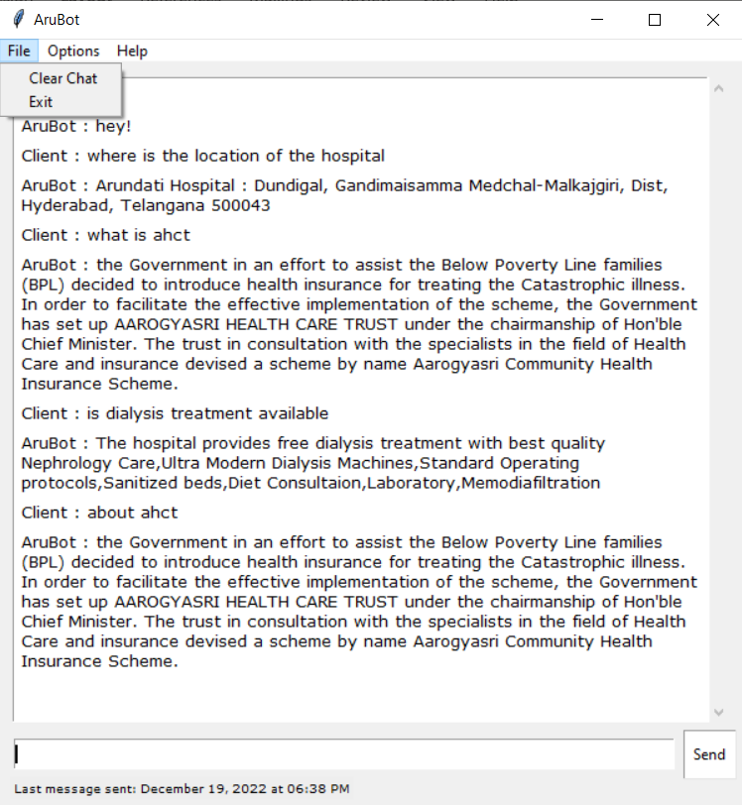

Fig 10.7 : file section of interface

1. In the options tab we can see different font styles and theme styles.

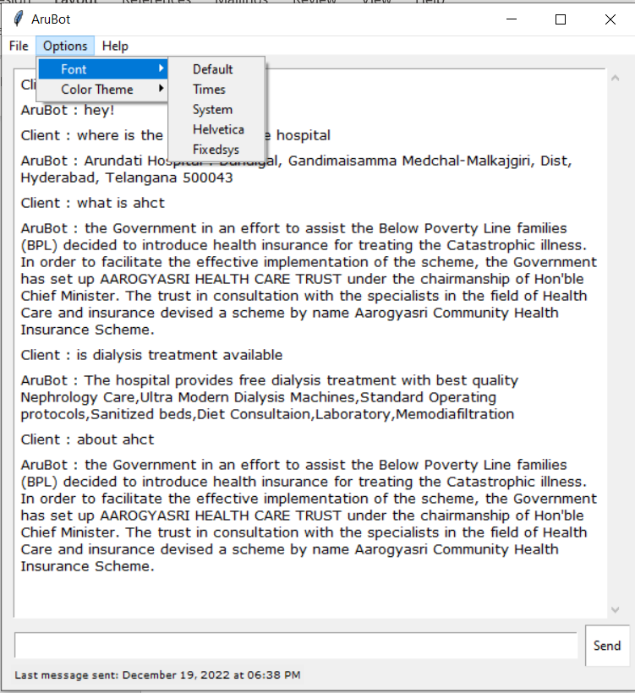

Fig 10.8 : options section 1

Different Themes are also available.

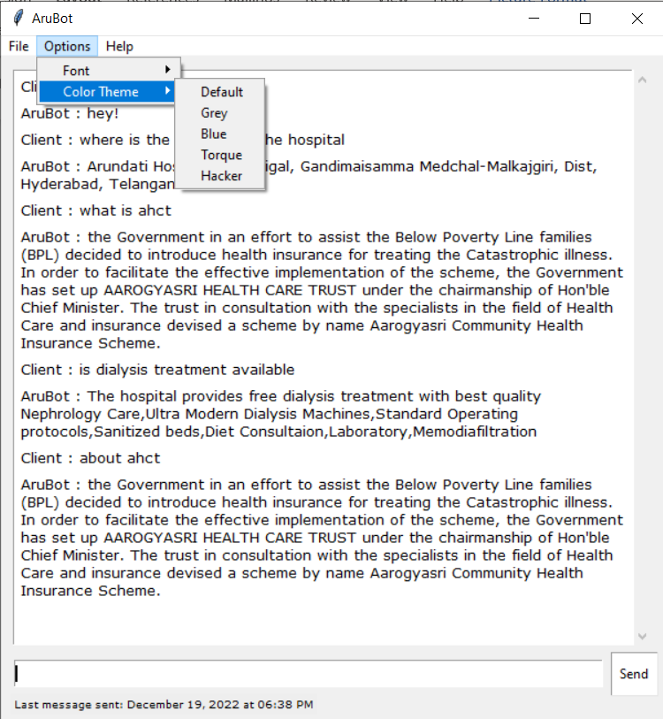

Fig 10.9 : options section 2

1. In the help option you will be able to see the Arubot developers and about arubot option.
2. If we click on Arubot developers the team members list is shown and if you click on about arubot we will be able to see about the bot.

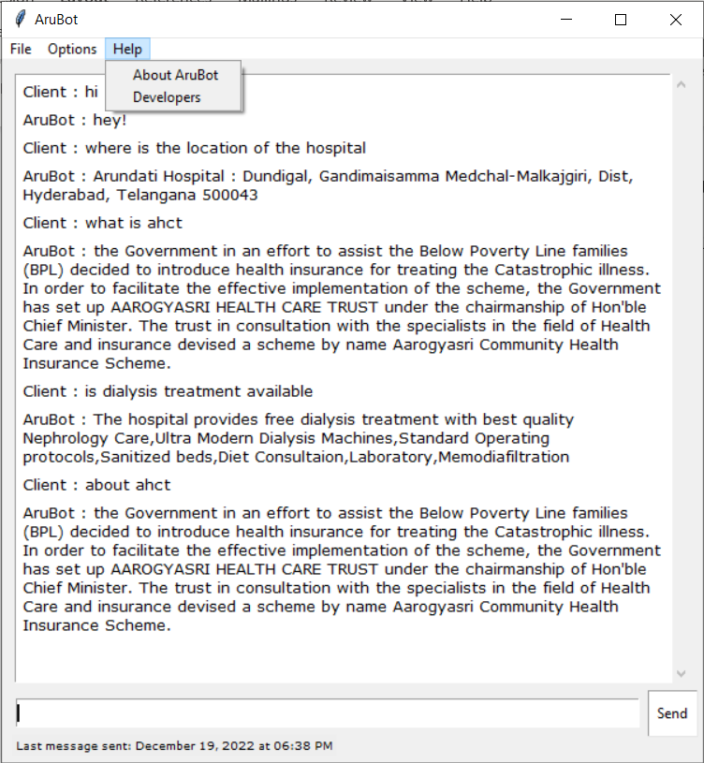

Fig 10.10 : Help section

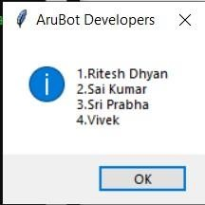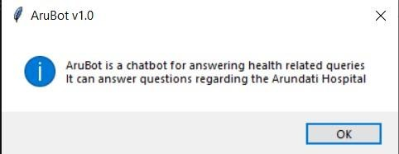

Fig 10.11 : about arubot

Fig 10.12 : arubot developers

**CHAPTER 9**

# CONCLUSION

Chatbots are going to explode and can be really dominating in future. Chatbots can provide a new and flexible way for users. They are giving AI something better to do. Chatbots results in smart conversation and is advancing at an unprecedented rate with each new development. They can be used in various domains like a chatbot for company or organizations, a chatbot for web application, a chatbot for hospital etc.

Chatbots are more effective than people in reaching out to the users via messaging apps or websites. They have the potential to become a useful information gathering tool in the near future. Chatbots are artificial intelligence that can provide highly tailored communication to the user while minimizing the workload of employees. The organizations or companies can easily offer high-quality support and conflict resolution any time of day, and for a large quantity of users simultaneously.

**CHAPTER 9**

# REFERENCES

[1] Chatbots : An Introduction and Easy Guide to make your Own – Oisin Muldowney.

[2] Designing Bots : Creating Conversational Experiences – Amir Shevat

[3] Conversational Interfaces : Principles of Successful Bots, Chatbots & Messaging apps – Mariya Yao

[4] Designing Conversational Interfaces – Alper Cugun

[5] Building Chatbots with Python : Using Natural Language Processing and Machine Learning - Sumit Raj

[6] Chatbots : 100 Successful Business and Brand bots by Adelyn Zhou

[7] The Conversational Interface : Talking to Smart Devices by Mc Tear, Michael, Callejas.